Racing

* Powerful motor, probably can’t change
* Low center of gravity if race involves turns
* F=ma, less mass=greater acceleration
* Evenly distribute weight across car
* Chassis made of carbon fiber, aluminum or reinforced plastic
* Aerodynamic
* Minimal tread to maximize surface contact
* Low tread depth
* Smaller tires for quick acceleration
* Wider tires for more surface contact
* Lighter tires
* Softer tires

Towing

* Heavy chassis
* Low center of gravity
* Soft compound tires
* Deep treads
* Wider tires

Overall

* Find a balance in weight for the chassis
* Wide tires
* Soft compound tires, if we can find a better material
* Even weight distribution

Trailer

* Match scale of rc car
* Reinforce axle and hitch
* Use aluminum or steel
* Keep lightweight and weight evenly distributed
* Rails to prevent load from falling off
* More tires mean higher load capacity, more stability, better traction, also higher cost and more weight

Polymer body with Trine school pride

Set of rims and tires for racing

Set of rims and tires for towing

Aluminum bumper

Trailer to attach to hitch and tow designated load

Head lights and tail lights

Polymer Body:

Idea 1

Idea 2

Idea 3

Idea 4

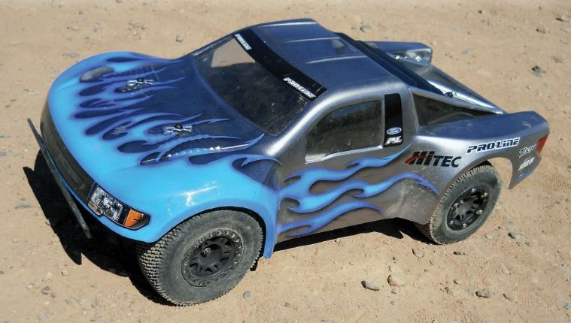

Trailer

Idea 1

Idea 2

